**OTHER SIDE OF WINDOW**

The beaming Phoebus arose amidst the vanishing black,

The congenial shaft of its dazzling self, illumined the placid lake;

And a troupe of gleeful children came frolicking in bliss.

The sailing boats of innocent hope ameliorated the charm of trees.

The mollifying vistas beyond the sanatorium’s casement,

As portrayed by the man tholing a pulmonary predicament;

To the convalescent lying supine in the adjacent bed,

With the ailment of vertebral fracture, he was afflicted.

The positive vibes from salubrious reverie rejuvenated his back,

But vast elapse of treacherous time filtered jealousy in;

When the spectator of the arcane window witnessed a pulmo attack,

All the solicitude bestowed on him went away in vain.

At his demise, the other man implored for the vacant bed,

But to the astonishment of his sight, he found a tenebrous wall ahead.

-Aadityaamlan Panda

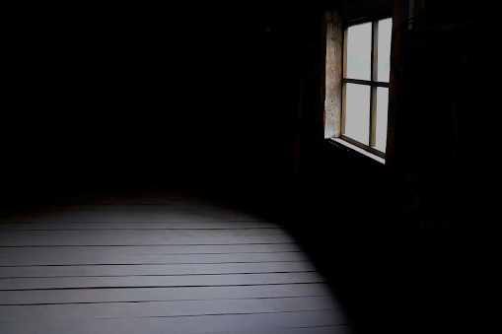

**OTHER SIDE OF WINDOW**

The beaming Phoebus arose amidst the vanishing black,

The congenial shaft of its dazzling self, illumined the placid lake;

And a troupe of gleeful children came frolicking in bliss.

The sailing boats of innocent hope ameliorated the charm of trees.

The mollifying vistas beyond the sanatorium’s casement,

As portrayed by the man tholing a pulmonary predicament;

To the convalescent lying supine in the adjacent bed,

With the ailment of vertebral fracture, he was afflicted.

The positive vibes from salubrious reverie rejuvenated his back,

But vast elapse of treacherous time filtered jealousy in;

When the spectator of the arcane window witnessed a pulmo attack,

All the solicitude bestowed on him went away in vain.

At his demise, the other man implored for the vacant bed,

But to the astonishment of his sight, he found a tenebrous wall ahead.

-Aadityaamlan Panda